 | Workers’ Compensation Benefits Offset  Oregon Administrative Rules  Chapter 436, Division 100

Effective Jan. 1, 2016

TABLE OF CONTENTS

Rule Page
436-100-0001 Authority for Rules 1
436-100-0002 Purpose 1
436-100-0003 Applicability of Rules 1
436-100-0005 Definitions 1
436-100-0006 Administration of Rules 2
436-100-0008 Administrative Review 2
436-100-0010 Criteria for Eligibility 3
436-100-0020 Requirements of Workers 3
436-100-0030 Authorization of Offset; Effective Date 3
436-100-0040 Sanctions Against Worker for Failure to Cooperate With the Department 4
ORDER OF ADOPTION 5
Certificate and Order for Filing Permanent Administrative Rules 7

NOTE: Significant revisions are marked by vertical lines in the right margin.

Historical rules: http://wcd.oregon.gov/laws/Documents/Rule_history/436_history.pdf

Blank page for two-sided printing

OREGON ADMINISTRATIVE RULES
CHAPTER 436, DIVISION 100

436-100-0001 Authority for Rules
(1) These rules are promulgated under the director’s authority contained in ORS 656.726 and 656.727.
Statutory authority: ORS 656.209, ORS 656.726 and ORS 656.727
Statutes implemented: ORS 656.209
Hist: WCB 7-1987, filed 6/5/78, eff. 6/6/78
WCD 4-1983 (Admin) (Temp), filed and eff. 9/1/83
WCD 2-1984 (Admin), filed and eff. 2/22/84

436-100-0002 Purpose
The purpose of these rules is to establish requirements and procedures for offsetting permanent total disability benefits against social security disability benefits.
Statutory authority: ORS 656.209 and ORS 656.727
Statutes implemented: ORS 656.209
Hist: WCB 7-1987, filed 6/5/78, eff. 6/6/78
WCD 4-1983 (Admin) (Temp), filed and eff. 9/1/83
WCD 2-1984 (Admin), filed and eff. 2/22/84
Amended 10/12/15 as WCD Admin. Order 15-064, eff. 1/1/16

436-100-0003 Applicability of Rules
(1) These rules are effective January 1, 2016, to carry out the provisions of ORS 656.209 and 656.727.
(2) These rules apply to:
(a) Those workers receiving awards for permanent total disability and eligible for and receiving federal social security disability benefits; and
(b) Injured workers whose period of disability under the Social Security Administration began on or after June 1, 1965.
(3) The director may waive procedural rules as justice requires, unless otherwise obligated by statute.
Statutory authority: ORS 656.209 and ORS 656.727
Statutes implemented: ORS 656.209
Hist: WCB 7-1987, filed 6/5/78, eff. 6/6/78
WCD 4-1983 (Admin) (Temp), filed and eff. 9/1/83
WCD 2-1984 (Admin), filed and eff. 2/22/84
Amended 12/4/97 as WCD Admin. Order 97-063, eff. 1/1/98
Amended 10/12/15 as WCD Admin. Order 15-064, eff. 1/1/16

436-100-0005 Definitions
(1) "Authorization" means an order issued by the Workers’ Compensation Division directing the paying agent to offset the worker’s permanent total disability benefits by the amount specified in the order.
(2) "Beneficiary" means an injured worker, and the spouse, child or dependent of a worker, who is entitled to receive payments under ORS 656.001 through 656.794.
(3) "Department" means the Department of Consumer and Business Services.
(4) "Director" means the director of the Department of Consumer and Business Services or the director’s designee.
(5) "Division" means the Workers’ Compensation Division.
(6) "Federal Disability Benefit Limitation" means the amount determined under 42 USC 224(a) and Social Security Administration rules.
(7) "Offset" means a reduction of permanent total disability benefits based on the amount of federal social security disability benefits received by a worker.
(8) "Paying agency" or "paying agent" means the self-insured employer or insurer paying benefits to the worker or beneficiaries.
(9) "Performance Section" means the Performance Section of the Workers’ Compensation Division.
(10) "Permanent total disability benefits" means compensation to an injured worker awarded permanent total disability compensation under ORS 656.206.
(11) "Worker" means any worker receiving permanent total disability benefits.
Statutory authority: ORS 656.726
Statutes implemented: ORS 656.209
Hist: WCB 7-1987, filed 6/5/78, eff. 6/6/78
WCD 4-1983 (Admin) (Temp), filed and eff. 9/1/83
WCD 2-1984 (Admin), filed and eff. 2/22/84
Amended 12/4/97 as WCD Admin. Order 97-063, eff. 1/1/98
Amended 10/12/15 as WCD Admin. Order 15-064, eff. 1/1/16

436-100-0006 Administration of Rules
In administration of these rules, orders of the Workers’ Compensation Division are deemed orders of the director.
Statutory authority: ORS 656.726
Statutes implemented: ORS 656.209 and ORS 656.726
Hist: WCB 7-1987, filed 6/5/78, eff. 6/6/78
WCD 4-1983 (Admin) (Temp), filed and eff. 9/1/83
WCD 2-1984 (Admin), filed and eff. 2/22/84
Amended 10/12/15 as WCD Admin. Order 15-064, eff. 1/1/16

436-100-0008 Administrative Review
(1) Any worker aggrieved by any offset authorization of the division may apply to the Workers’ Compensation Division for a reconsideration of that authorization before requesting a hearing.
(2) Any party aggrieved may request a hearing under ORS 656.283.
Statutory authority: ORS 656.726 and ORS 656.727
Statutes implemented: ORS 656.209
Hist: WCB 7-1987, filed 6/5/78, eff. 6/6/78
WCD 4-1983 (Admin) (Temp), filed and eff. 9/1/83
WCD 2-1984 (Admin), filed and eff. 2/22/84
Amended 12/4/97 as WCD Admin. Order 97-063, eff. 1/1/98
Amended 10/12/15 as WCD Admin. Order 15-064, eff. 1/1/16

436-100-0010 Criteria for Eligibility
(1) Permanent total disability benefits must be offset by the workers’ social security disability benefits. However, the total combined benefit, permanent total disability benefits plus social security disability benefits, must not be offset to an amount less than the greater of:
(a) The amount the worker would have received under ORS chapter 656; or
(b) The Federal Disability Benefit Limitation.
(2) Permanent total disability benefits must not be paid by the paying agent in an amount greater than authorized by ORS Chapter 656.
(3) Offset of permanent total disability benefits must be made by a paying agent only in an amount and as authorized by the director.
(4) Offset of permanent total disability benefits will be authorized by the director only upon actual receipt of federal social security disability benefits by the injured worker.
Statutory authority: ORS 656.209 and ORS 656.727
Statutes implemented: ORS 656.209
Hist: WCB 7-1987, f. 6/5/78, eff. 6/6/78
WCD 4-1983 (Admin) (Temp), filed and eff. 9/1/83
WCD 2-1984 (Admin), filed and eff. 2/22/84
Amended 10/12/15 as WCD Admin. Order 15-064, eff. 1/1/16

436-100-0020 Requirements of Workers
(1) Workers entitled to receive permanent total disability benefits must make application for federal social security disability benefits.
(2) Workers and eligible beneficiaries must, upon department request, execute a release form authorizing the Social Security Administration to make disclosure to the department of such information regarding the injured workers as will enable the department to carry out the provisions of ORS 656.209 and these rules.
(3) Whenever there is a change in the federal social security beneficiary eligibility, the worker must notify the Performance Section.
(4) Upon request of the department, the worker may be required at any time to furnish additional information regarding social security disability benefits.
Statutory authority: ORS 656.209 and ORS 656.727
Statutes implemented: ORS 656.209 and ORS 656.727
Hist: WCB 7-1987, filed 6/5/78, eff. 6/6/78
WCD 4-1983 (Admin) (Temp), filed and eff. 9/1/83
WCD 2-1984 (Admin), filed and eff. 2/22/84
Amended 10/12/15 as WCD Admin. Order 15-064, eff. 1/1/16

436-100-0030 Authorization of Offset; Effective Date
(1) Authorization issued by the department will be directed to the paying agent with a copy to the injured worker.
(2) A paying agent making payment of permanent total disability benefits will be entitled to social security disability offset only as authorized by the department.
(3) The department will review the social security offset calculation when notified of a change in the status of a worker subject to social security offset. An amended authorization will be issued, if necessary.
(4) Whenever there is a change in eligibility status of the worker or any one of the worker’s beneficiaries receiving benefits for permanent total disability subject to offset, the paying agent must notify the Performance Section.
(5) The paying agent must, immediately upon the death of a worker, terminate payment of previously authorized permanent total disability benefits offset and begin payment of other compensation due under ORS chapter 656, if any.
(6) The effective date of offset must be the effective date established in the authorization.
Statutory authority: ORS 656.209 and ORS 656.727
Statutes implemented: ORS 656.209 and ORS 656.727
Hist: WCB 7-1987, filed 6/5/78, eff. 6/6/78
WCD 4-1983 (Admin) (Temp), filed and eff. 9/1/83
WCD 2-1984 (Admin), filed and eff. 2/22/84
Amended 10/12/15 as WCD Admin. Order 15-064, eff. 1/1/16

436-100-0040 Sanctions Against Worker for Failure to Cooperate With the Department
(1) Any worker entitled to receive permanent total disability benefits who fails to comply with these rules will be subject to suspension of benefits until the worker has complied.
(2) If a worker fails to comply with these rules, the director will make a written demand upon the worker by personal service or registered mail. If the worker fails to comply within 20 days of receipt of the demand, the director may authorize suspension of benefits until the worker complies.
(3) An order of suspension of benefits will continue in force from the date issued until the date the worker actually complies with these rules.
(4) No compensation will become due or be payable during a period of suspension of benefits.
Statutory authority: ORS 656.209 and ORS 656.727
Statutes implemented: ORS 656.209 and ORS 656.727
Hist: WCB 7-1987, filed 6/5/78, eff. 6/6/78
WCD 4-1983 (Admin) (Temp), filed and eff. 9/1/83
WCD 2-1984 (Admin), filed and eff. 2/22/84
Amended 10/12/15 as WCD Admin. Order 15-064, eff. 1/1/16
BEFORE THE DIRECTOR
DEPARTMENT OF CONSUMER AND BUSINESS SERVICES
WORKERS’ COMPENSATION DIVISION

In the Matter of the Amendment of Oregon Administrative Rules (OAR):  436-100, Workers’ Compensation Benefits Offset, | )  )  )  ) | ORDER OF  ADOPTION  No. 15-064

The Director of the Department of Consumer and Business Services, under the general rulemaking authority in ORS 656.726(4), and in accordance with the procedures in ORS 183.335, amends OAR chapter 436, division 100.
On Aug. 11, 2015, the Workers’ Compensation Division filed with the Secretary of State a Notice of Proposed Rulemaking Hearing and Statement of Need and Fiscal Impact. The division mailed copies of the Notice and Statement to interested persons and legislators in accordance with ORS 183.335 and OAR 436-001-0009, and posted copies to its website. The Secretary of State included notice of the public hearing in its September 2015 Oregon Bulletin. On Sept. 22, 2015, a public hearing was held as announced. The record remained open for written testimony through Sept. 28, 2015.

SUMMARY OF RULE AMENDMENTS
These amendments:
- Implement Enrolled House Bill 2478 by amending the definition of "Beneficiary" to refer to the "spouse" of a worker rather than to the "husband" or "wife" of a worker;
- Update other definitions; and
- Make plain language changes to improve readability.

FINDINGS
Having reviewed and considered the record and being fully informed, I make the following findings:
a) The applicable rulemaking procedures have been followed.
b) These rules are within the director’s authority.
c) The rules being adopted are a reasonable administrative interpretation of the statutes and are required to carry out statutory responsibilities.

IT IS THEREFORE ORDERED THAT
1) Amendments to OAR chapter 436, division 100 are adopted as administrative order
No. 15-064 on this 12th day of October, 2015, to be effective Jan. 1, 2016.
2) A certified copy of the adopted rules will be filed with the Secretary of State.
3) A copy of the adopted rules with revision marks will be filed with the Legislative Counsel under ORS 183.715 within ten days after filing with the Secretary of State.
DATED this 12th day of October, 2015.
/s/ John L. Shilts
John L. Shilts, Administrator
Workers’ Compensation Division

Under the Americans with Disabilities Act guidelines, alternative format copies of the rules will be made available to qualified individuals upon request.
If you have questions about these rules or need them in an alternate format, contact the Workers’ Compensation Division, 503-947-7810.

Distribution: Workers' Compensation Division e-mail distribution lists, including advisory committee members and testifiers

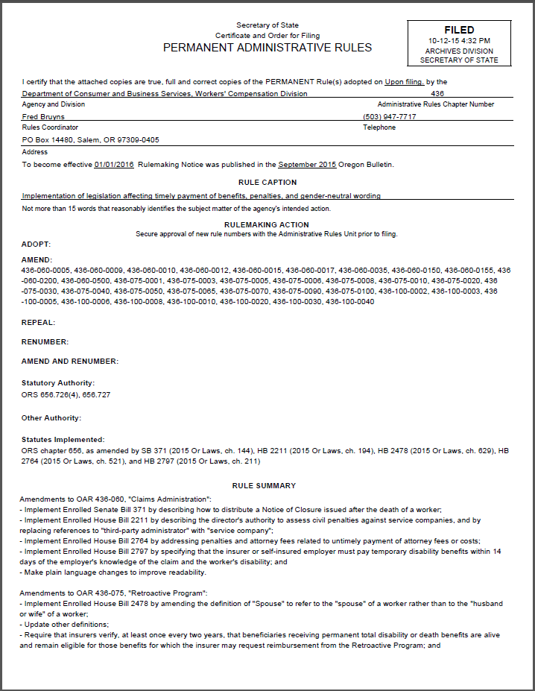
Certificate and Order for Filing Permanent Administrative Rules
