 |  |  |  |  | Visual  Impairment
Worker’s name: |  |  | DOI: |  | WCD #:

Note: All visual loss is measured with best correction, using the lenses recommended by the worker’s physician.
Visual acuity: Report the central visual acuity for each eye, distance and near vision. L.E. R.E.
Distance vision, reported in standard increments of Snellen notation | / | /
If distance vision is less than 20/400, can the worker count fingers at four feet? | yes no | yes no
Near vision, reported in Snellen 14/14 notation. Revised Jaeger or American point type units
Natural lens | yes no | yes no
Implanted prosthetic lens | yes no | yes no
Aphakia | yes no | yes no

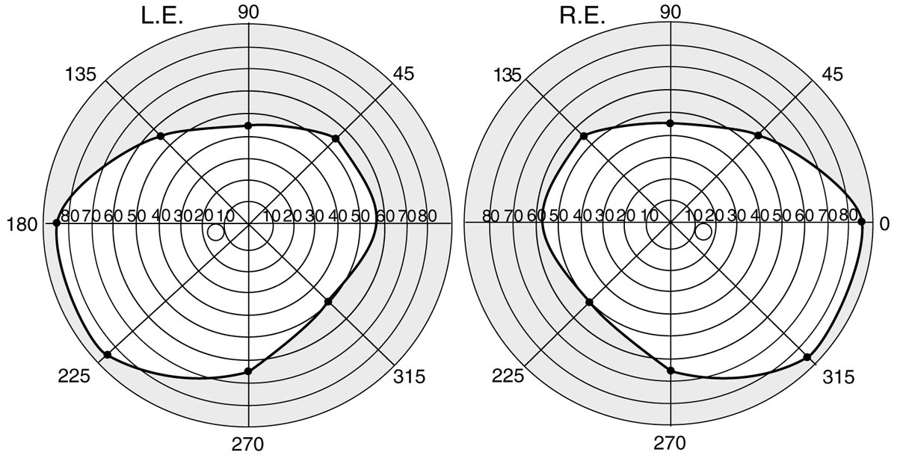
Visual field deficits: N/A  Measure each visual field using a Goldmann perimeter with a  lll / 4e stimulus. Report the results on either:  - a perimetric chart which indicates the extent of retained vision out to 90 degrees for each of the eight standard 45-degree meridians, as reproduced above, or  - a monocular Esterman grid |  |  |  |  |  | Ocular motility: N/A  Report binocular diplopia in degrees  along the eight standard meridians, as reproduced above.
Impairments of lacrimal system: N/A
If too little or too much tearing restricts the worker from  any part of regular work, specify the affected eye and whether the condition: |  |  |  | Additional ocular disturbances N/A
 |  |  |  | Indicate the affected eye:
 |  |  |  |  |  |  | None | Mild |  | Moderate | Severe
 | is a nuisance but does not prevent most regular work activities |  |  | Glare (photophobia)
 | prevents some regular work-related activities |  |  | Monocular diplopia
 | prevents most regular work-related activities |  |  | Stereopsis
Examining physician name and title (print or type):
Signature: |  |  |  |  | Date of examination:
440-2312 (12/23/DCBS/WCD/WEB)

